**Objective:**

1. Designing a method that can effectively estimate the relative soft-landing influence on pore pressure development at measuring point.
2. Prove that the difference due to the landing effect causes the difference in pore pressure response.
3. **Problem statement**

In report sent on 09282020, loading condition (figure 1) was designed to test the soft-landing effect, in which tire pressure was intently dropped down to zero (at 101T), through this landing effect can be captured. However, such pulse loading effect (at 101T) causes huge numerical oscillation (detail refer to report), which makes the measurement meaningless.

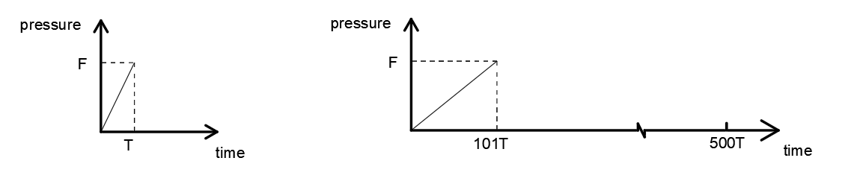

Where numerical oscillation happens

Fig 1. (copied from report sent on 09282020, figure 5d)

1. **A designed method to evaluate the relative soft-landing effect**

Catching soft-landing effect is numerically difficult. To avoid such oscillation (Figure 1), constant load with magnitude F is used (Figure 2 a1, b1, c1, d1, e1) after load reaches F (100 psi) till the end of loading period. The total constant loading time is 0.4 s for all cases, which equals to the load-move time (in moving load case distance:400 in, speed :1000 in/s – 60 mph).

A sensitivity analysis on loading time is performed (figure 2, a1/b1/c1/d1) with each corresponding dynamic pore pressure shown in figure 2 (a2/b2/c2/d2).

Ideally, if landing process does not affect the measuring point, by subtracting dynamic pore pressure responses under constant loading (0.4 second total) between each two cases in figure 2, the result will be a horizontal line with zero value. However, in computational tests, soft landing process affects the pore pressure at a certain level, typically a longer landing time causes less impact on measuring point, therefore, in figure 2 e1, a “sufficient long” time 1.2 second is used on landing process to try to represent the ideal case, and the dynamic pore pressure response under constant loading (0.4 second total) is set as a “standard solution” which is then subtracted from the rest cases respectively.

Figure 3 shows the results of the subtraction of pore pressure under constant loading between each case and the “standard solution”, assuming that the “standard solution” is oscillation free, the subtraction result reveal the oscillation level of each case due to the landing condition. Some findings are listed below:

1. In Figure 3a, a huge oscillation due to the hard landing is shown, by increasing landing time from 0.1 seconds (figure 3b) up to 0.6 seconds (figure 3c), the magnitude of oscillation all appear at beginning decreases from 0.48 down to 0.18 psi.
2. The trend described in 1) meets the expectation that longer landing time yields less oscillation.
3. Results from figure 3a (b2, c2, d2) show that landing effect on pore pressure decreases with time. Oscillation for center (0.2 second) is around 0.35 psi/0.25 psi/ 0.15 psi for landing time 0.1s/0.3s/0.6s respectively.

The method is used to estimate the relative soft-landing effect on measuring point, where “relative effect” is due to the fact that the “standard solution” is not really standard, since only 1.2 seconds are used on landing process, it is more of a compromise to the computational time (unrealistic to run a case with infinite soft landing time). Though the absolute soft-landing effect on measuring point is still not able to predict, the method offers a deeper insight to the oscillation caused by soft landing.

|  |  |
| --- | --- |
|  |  |
| (a1) | (a2) pore pressure development |
|  |  |
|  |  |
| (b1) | (b2) |
|  |  |
|  |  |
| (c1) | (c2) |
|  |  |
|  |  |
| (d1) | (d2) |
|  |  |
|  |  |
| (e1) | (e2) |

Fig 2. Hard/soft landing and pore pressure responses

|  |  |
| --- | --- |
|  |  |
| (a1) | (a2) |
|  |  |
|  |  |
| (b1) | (b2) |
|  |  |
|  |  |
| (c1) | (c2) |
|  |  |
|  |  |
| (d1) | (d2) |

Fig 3. Hard/soft landing effect on measuring point

1. **differences between landing effect VS corresponding differences in pore pressure response**

In order to further prove, the differences from figure 3 b2,c2,d2 are plot in figure 4a, and the moving load case under different soft landing time are copied from previous report (report sent on 09282020, figure 4a) in figure 4c, where its partial magnified plot are shown in figure 4d and 4b.

Here in figure 4a, the difference between each line represent the difference between each soft-landing condition, for example difference 01 represent the pore pressure difference between 0.1 s and 0.3 s. From the previous study, different soft landing conditions are also compared in figure 4b where the differences between peak points are measured in figure (-50 in to 0 in), they are the same as the differences in figure 4a (0.15 -0.2 s), which means that the difference between soft landing effect causes the equivalent difference in dynamic pore pressure.

Note: In this comparison, time in figure 4a and the distance in figure 4c have relationship as below:

|  |  |  |  |  |  |  |  |  |  |
| --- | --- | --- | --- | --- | --- | --- | --- | --- | --- |
| Time (s) | 0 | 0.05 | 0.1 | 0.15 | 0.2 | 0.25 | 0.3 | 0.35 | 0.4 |
| Distance (in) | -200 | -150 | -100 | -50 | 0 | 50 | 100 | 150 | 200 |

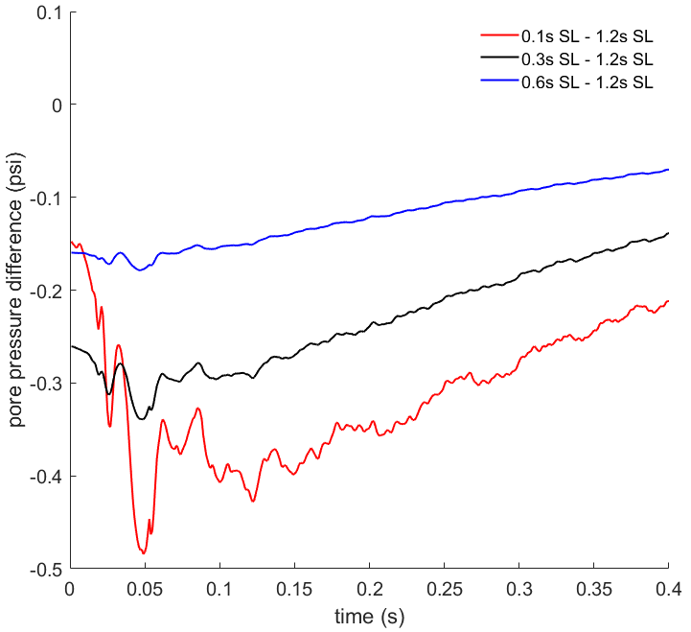 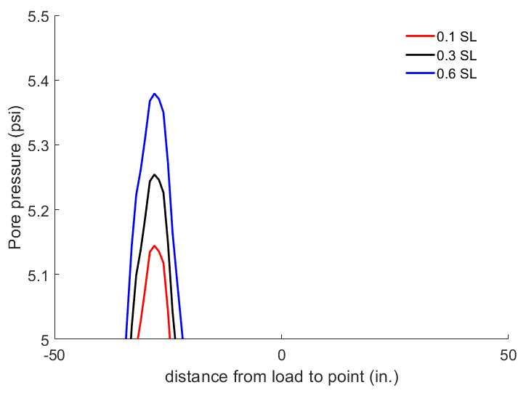

Difference02

Difference01

Difference02

Difference01

1. (b)

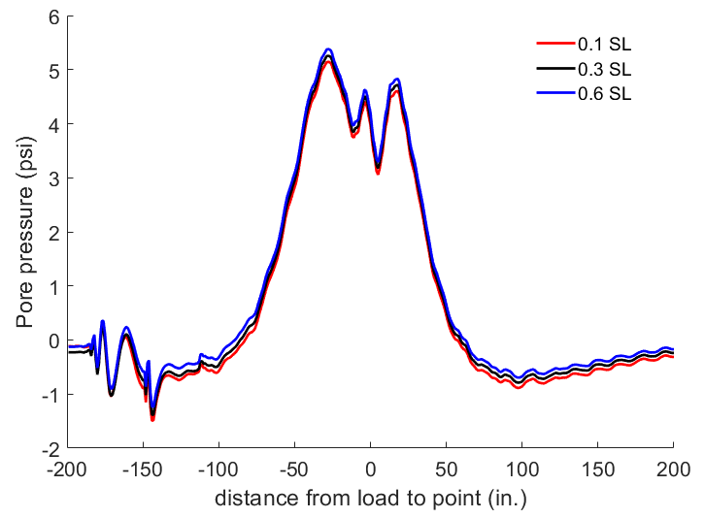 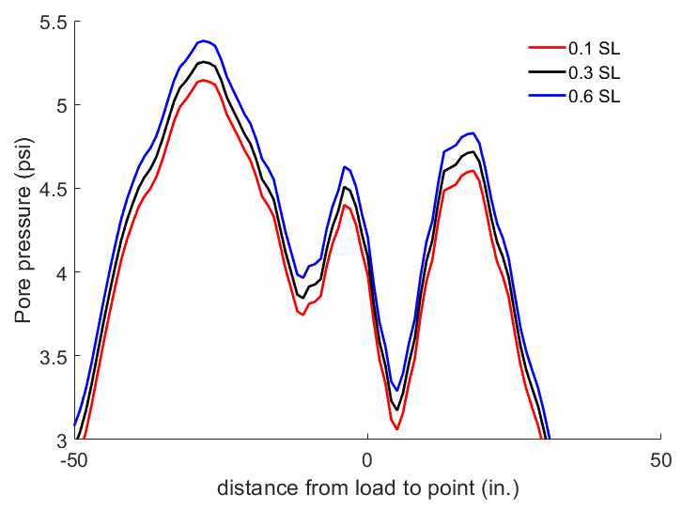

(c) (d)

Figure 4 compare different landing effects

1. **Conclusion**
2. Longer landing time can decrease its impact on pore pressure development.
3. When landing time is 0.1 second (typically used in former report), the magnitude of oscillation is around 0.5 psi, oscillation around peak point is 0.35 psi.
4. Difference between soft landing effect causes the equivalent difference in dynamic pore pressure.